Job Description | Operations Assistant
 | Part-time
Company Background

Serve Legal is the UK’s leading retail compliance auditor, enabling market leaders to successfully measure and improve performance, and protect their businesses. We perform independent, undercover on-site audits enabling companies to establish if expected staff performance, operational standards and company procedures are in place.

Serve Legal is a dynamic, growing company delivering over 200,000 audits a year with a UK- wide team of around 2,500 auditors. With expertise in age-restricted sales, retail audit, media compliance and customer experience fields, we are expanding our business into new territories.

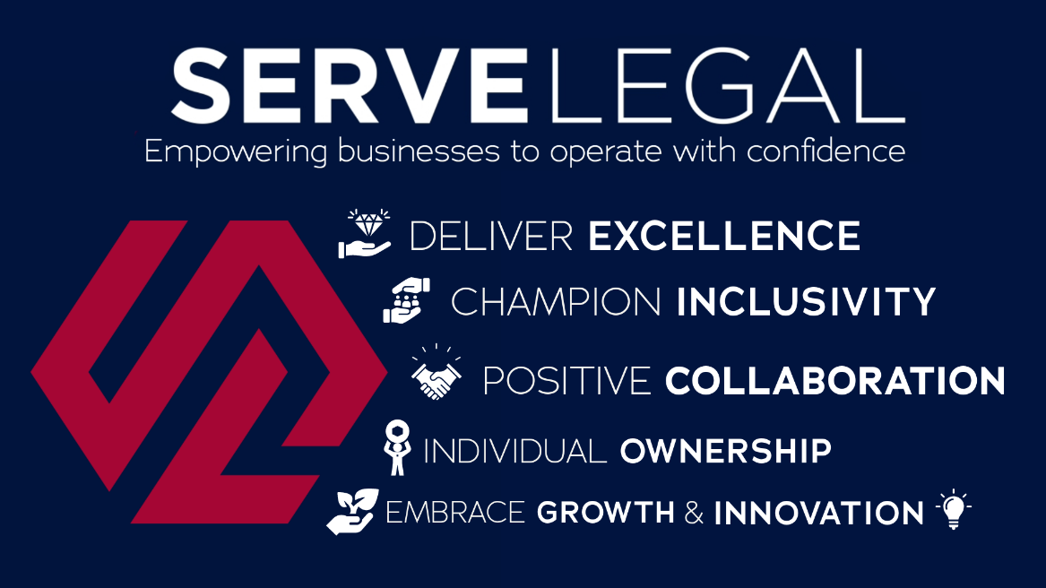

Job Purpose:
To work with Area Managers and the wider Operations team, assigning audits, approving submitted reports to the highest standards and in line with company objectives, and helping with other operational tasks where required.

Principal Accountabilities:
To support the Operations Team as required. The relevant Manager will ensure you are aware of exactly what is required, issue clear instructions and set achievable deadlines for the completion of tasks.

You must:
- Communicate regularly when working to ensure your time is used effectively.
- Check emails and texts daily for communications from Serve Legal in line with the Communications Policy
You will have the opportunity to increase your hours when the volume is high and are expected to respond positively to the needs of the company, both at weekends and during the week.
Other Comments:
Hours are contracted to 25 hours per week. Additional weekend work may be available from time to time.

Salary
We follow real living wage guidelines.

Behavioural and work-based competencies

- Good time management and organisational skills; an incisive self-starter with the ability to prioritise tasks, demonstrate tenacity and meet deadlines.
- Ability to cultivate strong working relationships; a positive and dynamic leader who inspires confidence.
- Decisive; cool under pressure. Reliable and tenacious
- Good communication skills; the ability to communicate clearly whether face to face, by phone or in writing.
- Collaborative. Able to motivate and collaborate with others to achieve group targets; take a balanced and objective view; take pride in collective success.
- Good understanding of Outlook, Word, Excel; has an understanding of Microsoft Office programmes and the ability to expand knowledge in these areas.
- Flexibility; able to adapt working hours regularly to the needs of the company and project at hand.

Other Requirements:

- The main place of work is the Operations Assistant home.
- You must have access to the internet at home.
- Monthly meetings are held in our London Office. Attendance at meetings and company events may be required.

